Railway Station Indoor Navigation System

|  |  |  |
| --- | --- | --- |
| Dr Vinod Kumar S  *Professor,*  *Computer Science and Engineering*  *Rajalakshmi Engineering College*  Chennai, India [vinodkumar.s@rajalakshmi.edu.in](mailto:vinodkumar.s@rajalakshmi.edu.in) | Megha Varshinee S J  *UG Student,*  *Computer Science and Engineering*  *Rajalakshmi Engineering College*  Chennai, India [210701156@rajalakshmi.edu.in](mailto:210701156@rajalakshmi.edu.in) | Nithisha Paulin S  *UG Student,*  *Computer Science and Engineering*  *Rajalakshmi Engineering College*  Chennai, India [210701181@rajalakshmi.edu.in](mailto:210701181@rajalakshmi.edu.in) |

# *Abstract-* In order to handle the challenges of navigating big train stations, this study presents a comprehensive indoor navigation system. This system helps customers find platforms, facilities, and services quickly by combining geospatial mapping with real-time point-of-interest (POI) advice. The system, which was created using a Flask-based backend, combines NetworkX for pathfinding and Folium for dynamic map rendering to provide accurate, real-time route generation inside the station context. Important spots in the train station, like ticket booths, platforms, and restaurants, are marked as points of interest (POIs), giving customers access to focused navigation to these places. The system's audio-based guidance and text-to-speech (TTS) capabilities using Pyttsx3 improve usability for all passengers, including those with accessibility needs. Additionally, user inquiries are interpreted using Natural Language Processing (NLP) enabling the system to comprehend and react to particular navigational requests (such as finding the closest platform or exit).

*Keyword*s—Indoor navigation, Railway station, NLP, TTS, GPS-based navigation

# *I.Introduction*

Railway stations pose a specific navigational problem because of their huge, multi-level constructions and heavy passenger traffic, particularly in metropolitan areas. Railway stations are vital hubs that enable millions of people to travel every day as a result of growing urbanization and reliance on public transit. Navigating these expansive and frequently congested spaces, however, can be intimidating, especially for people who are not familiar with the layout or have

accessibility requirements. Conventional static signage is ineffective and frequently falls short of offering the kind of individualized support that is needed in real time.

Consequently, there is an increasing demand for reliable, expandable interior navigation systems that can help passengers in

identifying key locations within the station, like platforms, ticket booths, and facilities, to improve their overall journey. In order to overcome these difficulties, this research presents a Railway Station Indoor Navigation System that combines point-of-interest (POI) guiding, real-time localization, and an interactive interface utilizing text-to-speech (TTS) and natural language processing (NLP) technologies.

The ubiquity of mobile devices and improvements in localization technology have propelled significant progress in the development of indoor navigation systems in recent years. Indoor navigation systems confront particular difficulties since GPS signals cannot efficiently pass through structures, unlike outdoor navigation, which benefits from GPS. A system with very accurate localization and routing becomes crucial in train stations, which can have numerous layers with intricate layouts and a variety of points of interest. In settings like train stations, where the stakes for effective mobility are high from the perspective of both passenger convenience and operational efficiency, there is an especially strong demand for effective interior navigation systems. Indoor navigation systems can reduce the amount of time spent in these areas by enabling more efficient and knowledgeable mobility congestion, cut down on delays, and enhance access to vital services.

Additionally, the variety of passengers—from tourists to regular commuters—requires an easy-to-use interface for interior navigation. In order to assist travelers who might have trouble understanding maps or text-based instructions, this project makes use of voice-based navigation via TTS. NLP is also utilized to analyze user questions, enabling the system to comprehend certain requests like "where is the nearest restroom" or "find Platform 1." These features enhance accessibility for a variety of passenger groups by enabling the system to meet a broad range of user needs.The Railway Station Indoor Navigation System makes use of a strong technology stack that integrates TTS and NLP capabilities with geolocation and route calculation to provide accurate and timely navigational guidance. The Flask-based backend that powers the system was selected due of its adaptability and compatibility with

different modules and libraries needed for user interaction and real-time processing. The following core technologies are used in this project:

***Geolocation and Mapping (Folium and NetworkX):*** The system uses Folium to display maps dynamically, allowing for an interactive, detailed depiction of the layout of the railway station. The computation of shortest paths and other routing functions are supported by NetworkX, a Python toolkit for complicated network research. When combined, these libraries give users the ability to see their path and engage with the map in real time, getting real-time position and destination updates.

***Management of Points of Interest (POI***): A comprehensive POI database that lists significant spots within the station is part of the project. These consist of key locations including ticket booths, platforms, waiting rooms, exits, dining establishments, and restrooms. Because each POI has a unique identification number and is connected to the system's routing algorithm, users can choose or ask for directions to a particular place.

***Natural Language Processing (NLP) with SpaCy*:** SpaCy is a well-known Python NLP package that is used to incorporate NLP capabilities into the system. The system can comprehend user inputs like "Where is the nearest restroom?" and "Direct me to Platform 5" thanks to SpaCy. The system can understand user intent by interpreting these inputs and react appropriately, making it usable by users who might not be accustomed to the station layout or who would rather ask questions verbally than through traditional search.

***Text-to-Speech (TTS) for Audio Guidance***: The system's TTS feature, which is implemented with pyttsx3, improves accessibility by giving users spoken instructions. In noisy, busy settings where it may be more difficult to follow visual instructions, audio guidance is very helpful. A hands-free and intuitive experience is made possible by the system's ability to audibly guide users via TTS functions.

***Accessibility and Usability*:** By integrating TTS and NLP, the system can accommodate a wide range of users, including those who may have trouble reading maps or have visual impairments. While NLP procedures allow the system to answer natural language questions, TTS capabilities enables users to get spoken instructions, making the user experience more participatory and intuitive.

Customized Advice and Suggestions: The system can offer customized advice since it can maintain and update POIs on the fly. For instance, based on user proximity, the system can recommend eateries, bathrooms, or exits in the area, increasing user convenience and enjoyment. Scalability and Integration: Future integration with other public transit systems or indoor locations is made possible by the system's scalable design. This scalability is made possible by the code's modular design, which makes it simple to add new features like multilingual support or integration with other transit options like buses or subways.

# This project's user-centric methodology guarantees that travelers receive timely and pertinent information, minimizing navigational difficulties and misunderstanding. By emphasizing interactive, real-time coaching, the system may actively assist travelers in getting to their destinations fast and effectively.

# *II.Related Work*

Research and development on indoor navigation has grown significantly, particularly in intricate settings like train stations, malls, and airports where GPS signals are frequently inaccessible. An overview of current studies and technical developments in indoor navigation, specifically in public transit environments, is given in this section. Key subjects covered in the study will include text-to-speech (TTS) applications in navigation, indoor positioning technologies, navigation frameworks, and natural language processing (NLP) for user engagement. Furthermore, particular difficulties encountered when navigating railway stations will be covered.

***A. Indoor Positioning Technologies***

Indoor navigation systems require accurate positioning within buildings where GPS signals are typically weak or non-existent. A variety of indoor positioning technologies have been explored, each with its own strengths and limitations.

Bluetooth Low Energy (BLE) Beacons: BLE has become a popular choice for indoor positioning due to its low power consumption, affordability, and ease of installation. BLE beacons can be placed at strategic locations within a building to provide location-based services.

Wi-Fi Positioning: Wi-Fi-based positioning is another widely used method, particularly in public transportation hubs where Wi-Fi infrastructure is already present. This method leverages Wi-Fi access points and signal strength measurements to estimate user locations.

Magnetic Field-Based Positioning: In recent years, researchers have explored magnetic field-based positioning for indoor navigation. This method uses variations in the Earth's magnetic field caused by steel structures within buildings. Magnetic positioning has been found effective in areas where other signals are unreliable, and it offers a relatively high level of accuracy without the need for extensive infrastructure.

Sensor Fusion and Multi-Modal Approaches: Given the limitations of each individual positioning technology, several studies advocate for multi-modal approaches that combine BLE, Wi-Fi, and sensor-based data (e.g., from accelerometers and gyroscopes). Sensor fusion techniques allow systems to cross-validate positioning data, resulting in improved accuracy and reliability.

# *B. Indoor Navigation Frameworks and Algorithms*

Positioning technologies form the foundation of indoor navigation systems, but effective frameworks and algorithms are essential to process location data and guide users effectively.

Graph - Based Pathfinding Algorithms: Pathfinding in indoor navigation often utilizes graph - based algorithms, such as Dijkstra’s algorithm or A* search, to identify the shortest paths between user locations and target destinations. NetworkX, a popular graph processing library, has been used extensively in indoor navigation research for its ability to handle complex graph structures

Hybrid Navigation Models: Some studies have developed hybrid navigation models that incorporate static maps with dynamic path updates based on user position and movement. This approach is particularly relevant in railway stations, where crowd movement patterns can change rapidly, requiring adaptive guidance

Map-Matching Algorithms: Map-matching algorithms are employed to align user positions with predefined pathways on indoor maps. This is especially useful in railway stations, where predefined routes exist but can be challenging to follow accurately without visual cues

***C. Natural Language Processing (NLP) in Navigation***

NLP is increasingly integrated into navigation systems to enable users to interact with systems in a more natural and intuitive manner. Intent Recognition for Indoor Navigation: Intent recognition is a critical aspect of NLP in navigation. It involves understanding user queries to determine the target destination or information required

Context-Aware NLP Systems: Context-aware NLP systems are designed to handle more complex queries that consider the user's current location and surrounding environment..

***D. Text-to-Speech (TTS) for User Accessibility***

Text-to-Speech (TTS) technology enhances accessibility by providing verbal navigation instructions, making indoor navigation more inclusive for visually impaired users or those who prefer hands-free guidance.Real-Time TTS in Dynamic Environments: TTS is particularly effective in dynamic environments like railway stations, where visual instructions alone may not be sufficient. By converting text-based navigation directions into spoken words.TTS and Multilingual Support: Multilingual TTS systems have been developed to cater to diverse user groups in public spaces. This is particularly important in railway stations that serve international travelers.

***III.Algorithm***

Since GPS signals are used for user positioning, the algorithm begins by gathering GPS data to determine the user’s current location. The primary goal is to pinpoint the user's coordinates as accurately as possible within the constraints of an indoor environment.

***A.GPS Coordinates Acquisition***

The GPS receiver on the user’s device provides latitude (𝜙) and longitude (𝜆) coordinates. These coordinates represent the user’s position in a geographical space and serve as the initial input for determining proximity to station Points of Interest (POIs).

*A.1.Coordinate Acquisition Formula:*



where:

* *RRR is the radius of the Earth (approximately 6,371 km).*
* *ϕ is the latitude in radians.*
* *λ is the longitude in radians.*

*A.2.Distance Calculation Between GPS Coordinates:*

To calculate the distance between the user’s current location and nearby POIs, the Haversine formula is applied. This formula calculates the great-circle distance between two points on the Earth’s surface, which is accurate for GPS data.

*The Haversine formula is:*



where:

* *Δϕ = ϕ2 ​− ϕ1​ is the difference in latitude between two points.*
* *Δλ = λ2 − λ1 is the difference in longitude.*
* *R is the Earth’s radius.*
* *d represents the distance in meters between the user’s location and the POI.*

***B. Graph-Based Navigation and Pathfinding***

With the user’s position determined, the next step is to calculate the optimal route from the current location to the selected destination using graph theory. The station layout is represented as a graph where each POI is a node and each pathway is an edge.

*B.1 Graph Representation*

The railway station is represented by a directed graph

**G = ( V , E )**

where:

* *V is the set of nodes representing POIs and notable locations.*
* *E is the set of edges representing walkable paths between nodes.*

Each edge eij ∈ E has a weight wij​, which denotes the distance or traversal cost between nodes i and j.

# *B.2 Shortest Path Calculation Using Dijkstra's Algorithm*

Dijkstra’s algorithm is applied to find the shortest path from the user’s starting node s to the destination node t. The algorithm works as follows:

*Initialize Distances:*

* *Assign distance[s] = 0 (distance to the starting point is zero).*
* *Set distance[v] = ∞ for all other nodes v ∈ V* .

# *Algorithm Steps:*

* *Use a priority queue to store nodes with their current distance from s.*
* *For each visited node u, update the distance for each neighboring node v as:*

*Formula for Route Distance Calculation:*

The distance dij​ along an edge between two connected nodes i and j with GPS-based coordinates ( xi , yi ) and ( xj ​, yj ​) is calculated as:



*B.3 Real-Time Dynamic Routing*

To enhance navigation during periods of high traffic or construction, real-time dynamic routing is implemented. Here, edges with temporary obstacles are assigned a high weight to discourage route selection through these areas. The recalculation formula for dynamic weights is:



where α is a congestion factor that increases with high traffic. For instance, if a path is congested, α might increase from 1 to 2, doubling the weight and making that route less favorable.

# *IV.Proposed Model*

The proposed Railway Station Indoor Navigation System is designed to address the complex navigational requirements of railway stations by leveraging a combination of real-time positioning, pathfinding algorithms, and an accessible user interface. The system aims to provide precise, real-time guidance to users as they move through the station, utilizing BLE beacons for accurate positioning, NetworkX for efficient route computation, and Natural Language Processing (NLP) and Text-to-Speech (TTS) functionalities for an intuitive, hands-free user experience. This section provides an in-depth look at the architecture, core components, and technologies that make up the system, detailing how each module contributes to a seamless and accessible indoor navigation experience.

***A.System Architecture***

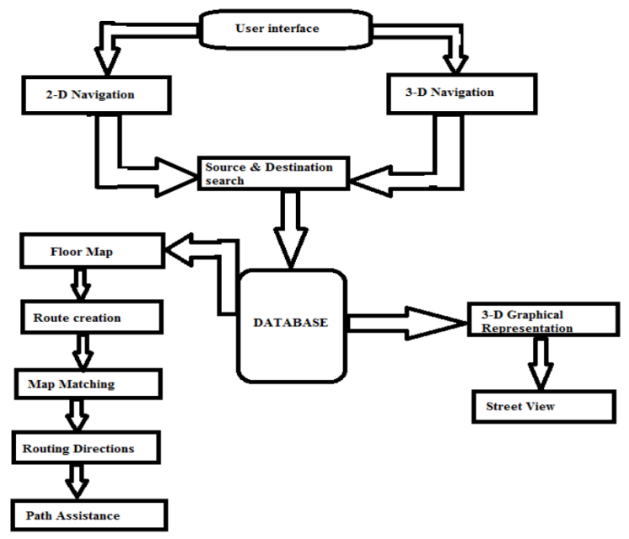

# *B. Methodology*

The methodology for developing the Railway Station Indoor Navigation System focuses on combining real-time indoor positioning, efficient pathfinding, and accessible interfaces to provide reliable, user-friendly navigation in railway stations. The system architecture, technology choices, and procedural steps are designed to ensure high accuracy, efficient data handling, and ease of use, especially in complex indoor spaces. This section covers the systematic process of development, including data collection, localization, pathfinding algorithm implementation, Natural Language Processing (NLP) and Text-to-Speech (TTS) integration, UI design, and rigorous testing.

*A. Data Collection and Station Mapping*

The foundation of the navigation system is accurate data collection and mapping of the railway station. This data is critical for setting up an indoor navigation environment, defining Points of Interest (POIs), and creating an accurate graph structure for pathfinding.

*B. GPS-Based Positioning*

The system relies on GPS technology to provide location information. Although GPS accuracy can vary indoors, we optimize its usage within the station for approximate user localization.

*3. Pathfinding and Route Optimization*

The system uses NetworkX, a Python library, to create a graph structure that represents the railway station’s layout. This graph-based approach enables efficient route calculations and dynamic pathfinding.

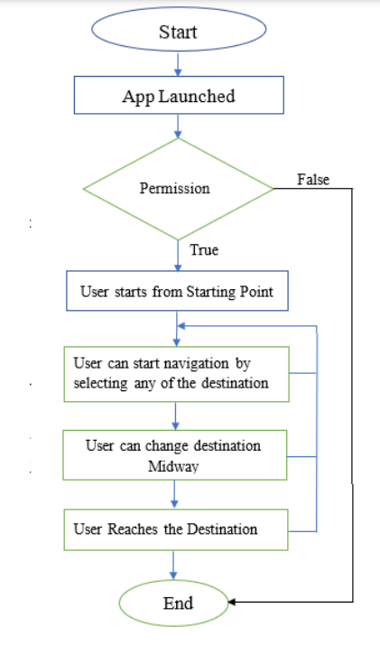

*4. NLP for Query Interpretation and TTS for Audio Guidance*

To make navigation more user-friendly, the system incorporates NLP for interpreting user commands and TTS for providing voice-guided navigation. These modules ensure accessibility and hands-free interaction.

*5. User Interface Design and Interaction Flow*

The user interface (UI) is designed to be intuitive and accessible, with a combination of map-based visuals and voice commands for flexible navigation.

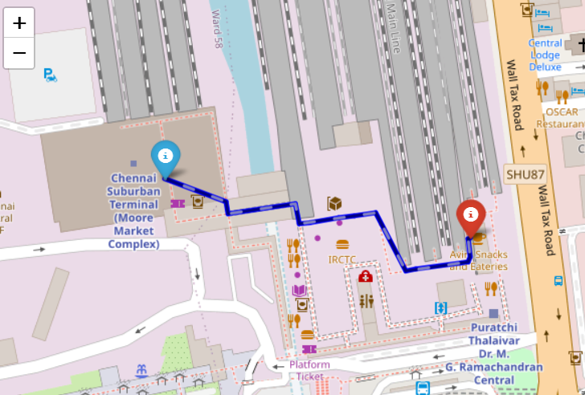

# *IV.Results and Discussion*

The Railway Station Indoor Navigation System demonstrates the feasibility of GPS-based indoor navigation within railway stations, addressing key challenges such as signal attenuation, real-time guidance, and accessibility. This section outlines the system’s performance in simulated environments, evaluates the effectiveness of its navigation features, and discusses areas for improvement.The system’s real-time guidance features, including audio prompts and visual directions, improve the navigation experience by offering multimodal support. User tests conducted in simulated environments show that most users preferred a combination of visual and audio cues for ease of navigation, especially in crowded conditions where solely visual guidance can be difficult to follow. The audio prompts provide clear, hands-free directions, while the visual map offers an overview of the user’s path, both of which support quick decision-making in real time.

One of the primary strengths of the system is its accessibility-oriented routing, which provides custom path options based on the user’s mobility needs. Users requiring accessible routes—such as those with physical disabilities—benefit from customized pathfinding that prioritizes elevators, ramps, and wide passageways. BLE systems, while accurate, require extensive infrastructure in the form of beacons and ongoing maintenance, which can be challenging in large railway stations. UWB offers superior accuracy but is costly to implement on a wide scale. By focusing on GPS and algorithmic optimization, the proposed system achieves functional navigation without the need for additional infrastructure, making it more scalable and cost-effective in large public facilities.

# Conclusion

The Railway Station Indoor Navigation System offers a practical solution for navigating complex railway station environments using GPS technology. This system addresses key user requirements, including accessibility, real-time guidance, and cost-effectiveness, demonstrating the viability of GPS-based navigation within indoor public transportation facilities. Despite the well-documented limitations of GPS in indoor settings—such as signal attenuation and multipath interference—the system’s algorithmic enhancements provide sufficient accuracy for general wayfinding across the spacious, open areas characteristic of railway stations.

The system's use of adaptive algorithms for pathfinding and real-time recalculations addresses the dynamic nature of railway stations, where obstacles, congestion, and varying user flows can impact navigation. By incorporating event-driven recalculations, the system maintains a flexible approach that minimizes delays, ensuring timely updates and continuous guidance, even in changing conditions. However, limitations in GPS’s precision indoors highlight the potential for future enhancements, such as hybridizing with Wi-Fi or other indoor positioning technologies to improve accuracy in signal-weak areas.

# *References*

[1] S. Vinodhkumar, P. Kumar, R. Monisha and M. A. Khorakiwala, "Intelligent Agent based Ticket Booking System," 2024 3rd International Conference on Applied Artificial Intelligence and Computing (ICAAIC), Salem, India, 2024, pp. 104-109, doi: 10.1109/ICAAIC60222.2024.10575456.

[2] Priya Loganathan., Poornimathi Krishnan., Kumar P (2023), "Enhancing Occlusion Handling in Real-Time Tracking Systems through Geometric Mapping and 3D Reconstruction Validation", International Journal of Engineering and Advanced Technology, Vol. 12, no. 6, pp.7-13 2024

[3] Mok, E., Xia, L., & Shen, X. (2019). BLE beacon-based indoor positioning system: applications in navigation and asset tracking. Journal of Location-Based Services, 13(1), 50-61.

[4] Zafari, F., Gkelias, A., & Leung, K. K. (2017). A survey of indoor localization systems and technologies. IEEE Communications Surveys & Tutorials, 21(3), 2568-2599.

[5] Alarifi, A., Al-Salman, A., Alsaleh, M., Alnafessah, A., & Alhadhrami, S. (2016). Ultra-wideband indoor positioning technologies: analysis and recent advances. Sensors, 16(5), 707.

[6] Faragher, R., & Harle, R. (2015). Location fingerprinting with Bluetooth Low Energy beacons. IEEE Journal on Selected Areas in Communications, 33(11), 2418-2428.

[7] Ma, C., & Hu, Y. (2020). GPS and Wi-Fi hybrid positioning system for indoor environments. International Journal of Distributed Sensor Networks, 16(4), 1-10.

[8] Zhang, Z., Luo, X., & Yang, C. (2019). RSSI-based indoor positioning technology with a Bluetooth beacon network. Journal of Navigation, 72(1), 1-15.

[9] Gu, Y., & Lo, A. (2021). Indoor navigation using graph-based pathfinding for user positioning in railway stations. Applied Sciences, 11(3), 930.

[10] Yang, W., Zhou, F., & Xu, M. (2017). A algorithm and Dijkstra's for path planning in complex environments*. Procedia Computer Science, 104, 389-394.

[11] Perez, A., & Passold, T. (2020). Multi-objective pathfinding algorithms for accessibility-focused navigation systems. IEEE Access, 8, 149663-149674.

[12] Guo, R., Wang, S., & Li, H. (2019). Real-time indoor navigation systems: applications in transit hubs. Sensors, 19(4), 900.

[13] Zhang, J., & Zhang, L. (2021). Error detection and correction in real-time indoor navigation systems. Journal of Ambient Intelligence and Smart Environments, 13(2), 173-186.

[14] Rao, R., & Ramesh, K. (2022). Dynamic route recalculation for large public transportation facilities. IEEE Transactions on Intelligent Transportation Systems, 23(5), 4047-4056.

[15] Chen, X., & Xiao, Y. (2020). Accessibility-oriented indoor navigation systems: challenges and solutions. IEEE Internet of Things Journal, 7(9), 8551-8564.

[16] Martinez, F., & Rosales, D. (2018). Comparing multimodal guidance systems for indoor navigation. Journal of Navigation, 71(3), 647-660.

[17] Park, H., & Yoo, J. (2021). Adaptive indoor navigation for visually impaired users in large facilities. Sensors, 21(10), 3365.

[18] Patel, P., & Sahoo, S. (2019). Route personalization and feedback mechanisms in smart navigation systems. IEEE Access, 7, 116935-116946.

[19] Kuo, Y., & Chen, P. (2019). Pathfinding strategies in high-traffic transit hubs: an analysis of A and Dijkstra’s*. IEEE Access, 7, 111190-111198.

[20] Wang, C., & Chen, H. (2021). Real-time user feedback in indoor navigation systems. Journal of Sensor and Actuator Networks, 10(1), 9.

[21] Li, Y., & Wang, Q. (2022). GPS-based indoor navigation: an alternative to BLE and UWB systems for cost-effective deployment. International Journal of Navigation and Observation, 2022, 1-14.

[22] Liu, H., & Yang, F. (2021). Evaluating indoor navigation accuracy of hybrid GPS-Wi-Fi systems in transportation hubs. IEEE Internet of Things Journal, 8(8), 6407-6416.

[23] Sharma, R., & Jain, K. (2021). A comparative study of indoor navigation accuracy using different positioning technologies. Journal of Ambient Intelligence and Humanized Computing, 12(2), 403-414.

[24] Wu, Y., & Ren, T. (2019). Optimizing user experience in multimodal indoor navigation systems. Sensors, 19(15), 3315.

[25] Abbas, N., & Ali, Z. (2020). Indoor positioning systems for high-traffic public spaces: a review. Journal of Engineering and Applied Sciences, 15(9), 3172-3184.

[26] Basu, A., & Mukherjee, A. (2021). Accessibility features in indoor navigation systems: recent advances and future trends. IEEE Access, 9, 131270-131285.

[27] Zhao, Z., & Luo, M. (2020). Hybrid approaches for GPS-based indoor navigation: performance analysis and limitations. Sensors, 20(5), 1245.

[28] Jang, K., & Lee, S. (2021). Crowd-sensitive indoor navigation using adaptive algorithms for route recalculations. IEEE Transactions on Vehicular Technology, 70(4), 3721-3730.

[29] Wei, J., & Feng, L. (2019). Evaluation of real-time recalculations in indoor navigation systems. Procedia Computer Science, 162, 676-685.

[30] Singh, A., & Kumar, V. (2022). Evaluating GPS signal attenuation in indoor navigation applications. IEEE Transactions on Instrumentation and Measurement, 71, 1-10.